# Implementation Model Document

Version 1.0

Draft

May 2017

Parmar Aman C.

Senior Developer

Test Manager

### Purpose

This Document is designed to present clear implement architecture and processes. This document will show how and why the system is implemented in a particular way.

It also demonstrates the overall design elements including objects and components that are connected to each other composing system as a whole.

### Scope

This document is limited to architectural details and thus does not provide information about any test programs, risk management programs nor any other system component’s origin details. This document is only for Book.trade system and does not apply to any other systems.

### Overview

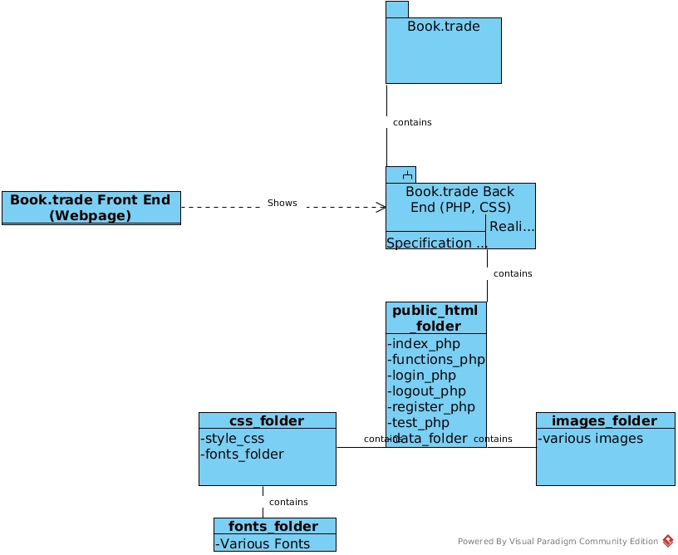This document will show in particular the implementation model, how it’s build works, it’s components and all related diagrams to present whole system.

### Implementation Explained

#### Booktrade Package:

Book.trade package is the final product produced by development team. This will include two parts

### Book.trade Front End package

Booktrade front end is the webpage used by users which interacts with UI and makes some partial changes to database. This front end is produced by booktrade back end. That means front end depends on back end will change in development or in future if back end changes.

### Book.trade Back End package

Booktrade back end is implemented by PHP, Html and CSS files. (PHP files includes the HTML data). A webpage is series of file paths displayed on a browser. It includes one root folder which is a read only access to users and contains various webpages and media files.

##### Public_Html folder:

Public_Html folder is start of the root folder that has user access. It various PHP and HTML files that builds up the webpage for users to interact. It also manages the connection to database. There’s one folder in there called data.

##### Data folder:

Data folder contains two more folders, one is called Css and other is called images. This folder can change in the future along with its content.

##### css folder:

CSS is html formatting language. It modifies how html elements are presented to the user. It has one style.css file that handles all the formatting of different pages.

##### font folder:

Font folder contains various fonts used in Booktrade website. These all fonts are free to use without copyright restrictions. This folder can change it’s content based on requirements.

##### Summary

Overall that is how Booktrade is implemented, for now. This is something that could change over time with new strategies and updates on architecture plans. Its main model is less likely to change but it’s components will change for sure.